A000-Eur-Crete-Agia Triada-Boxer Rhyton-1450 BCE



Figs. 1-2. Eur-Crete-Agia Triada-Boxer Rhyton-1450 BCE

**Case no.: 4.**

**Accession Number:**

**Formal Label:** Eur-Crete-Agia Triada-Boxer Rhyton-1450 BCE

**Display Description:**

This is the so-called “Boxer Rhyton,” of Agia Triada, ca 1450 BCE in which scenes of boxing, wrestling and bull-leaping are depicted. However, the main theme for our purposes is the Bull Cult, as it reflects a primary emphasis of Minoan religion.



In this rhyton the second register shows a jumper successfully somersaulting over the body of an Auroch (1b) and a second jumper being impaled on the horns of an Auroch (2b). This provides a basis for understanding the extreme training and athleticism required of these jumpers. However, the religious aspects underlying these feats of bull encounters requires some additional support.

This can be supplied by the Bull Cult’s religious aspects that are depicted on the Sarcophagus of Agia Triada (1600 - 1450 BCE) now in the Archaeological Museum of Herakleion,

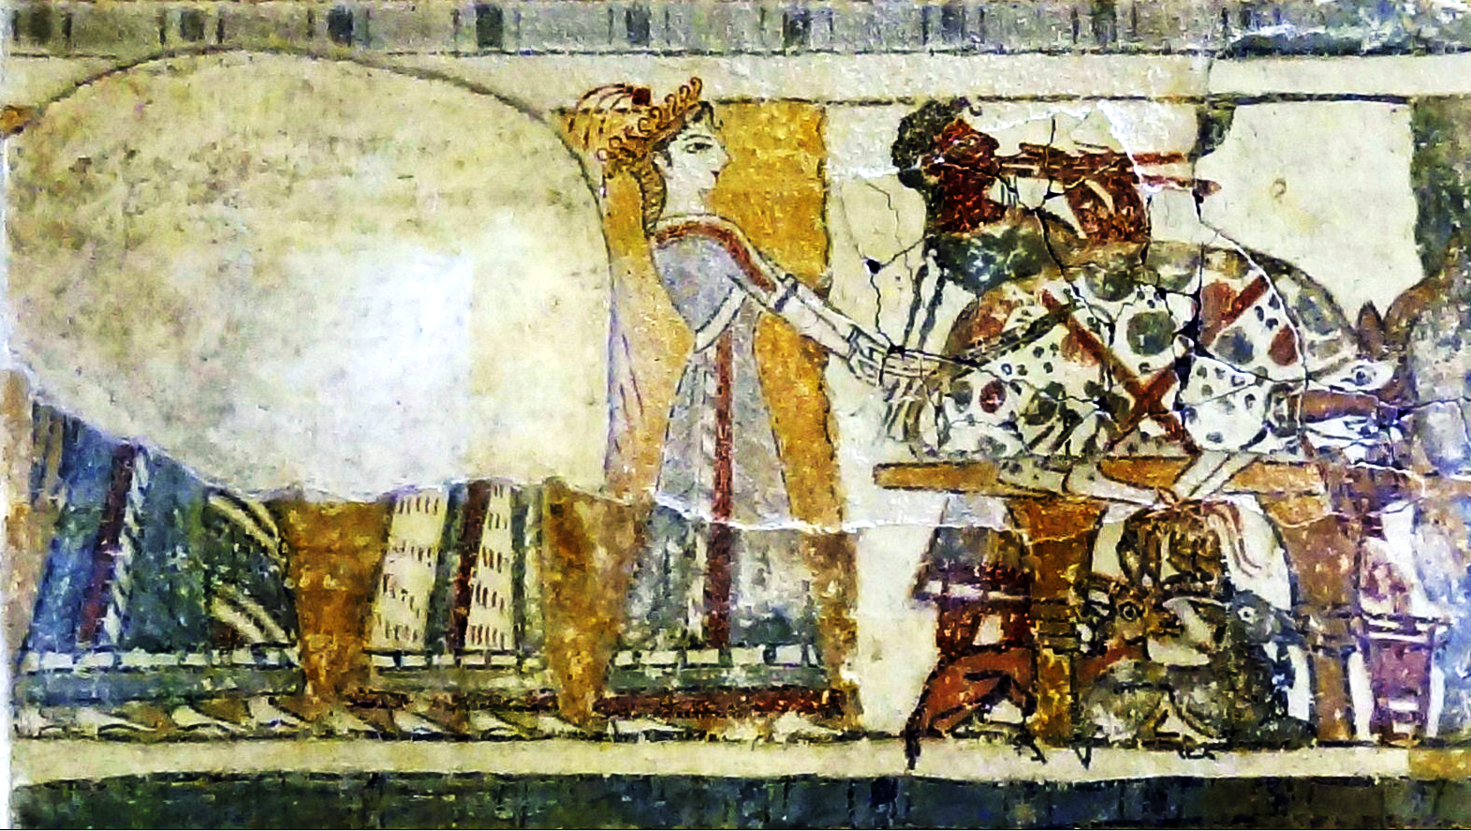

Side 1, left, of the Sarcophagus of Agia Triada. Four priestesses being led by a goddess with a plumed crown who is presenting a sacrificed bull on an offering table, as a flute player praises the sacrifice with music. This Late Bronze Age sarcophagus was found in a funerary chamber at Agia Triada in Crete. It was made of limestone, covered with a thin layer of lime plaster, and then painted. Sarcophagus of Agia Triada (1600 - 1450 BCE) – detail Side 1 left. Archaeological Museum of Herakleion,

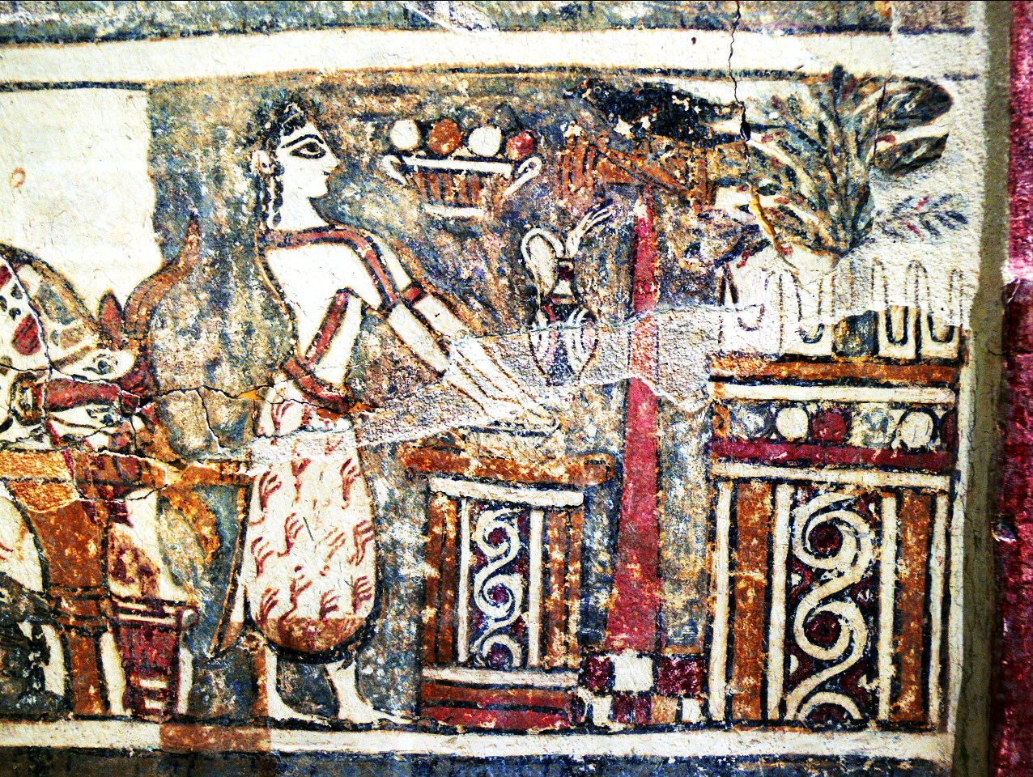

Side 1, right, of the Sarcophagus of Agia Triada. Sarcophagus of Agia Triada (1600 - 1450 BCE) – detail Side 1 right. Archaeological Museum of Herakleion, By Olaf Tausch [GFDL (http://www.gnu.org/copyleft/fdl.html) or CC BY 3.0 (https://creativecommons.org/licenses/by/3.0)], from Wikimedia Commons

Priestess dressed in a brown textured fur skirt and a brown-striped blouse. She is offering, presumably, sacrificial bulls’ blood in a special long-spouted, bird-beaked, Kamares-ware vessel before a Double Axe or Labrys Gnomon at a Bovine Horned Altar. A black raven, the special bird overseeing the bull’s blood oblation, is ensconced on top of the labrys and is in eye-contact with the priestess. Goddesses could assume the forms of birds such as doves and ravens, and it is they who appear perched on labrys here.

In ancient Crete of the Minoan world the bull held a special place of reverence. Bull-leaping (also taurokathapsia, greek ταυροκαθάψια  *“laying hold of the bull”*). ταῦρος (*taûros*, “bull”) +  *κατα* (kata, “across”) + ἅπτομαι (háptomai, “touch, reach”). The Cretan bulls were a breed of Auroch, a bovine that had a shoulder height of about 6 feet, but by about the 5th century BCE it was already extinct in Greece.

In the various bovine-shaped ceramic vessels with a provenance that connects them to the Minoan world blood from sacrificial bulls was ritually contained in ceramic rhyta (sing. ryton) in the shape of bulls to be poured over sacrificial offerings. Since bulls were ritually sacrificed, the ominous double axe may have been the ritual implement that was used in the sacrificial act since it is connected with the oblation of bull’s blood. The fourteenth century BCE funerary limestone Hagia Triada sarcophagus features on one panel women leading bulls to sacrifice and on the opposing panel women are carrying rhyta full of sacrificed bull’s blood to an altar preceded by a labrys gnomon before a bovine horn altar ready for a hematologic ablution.

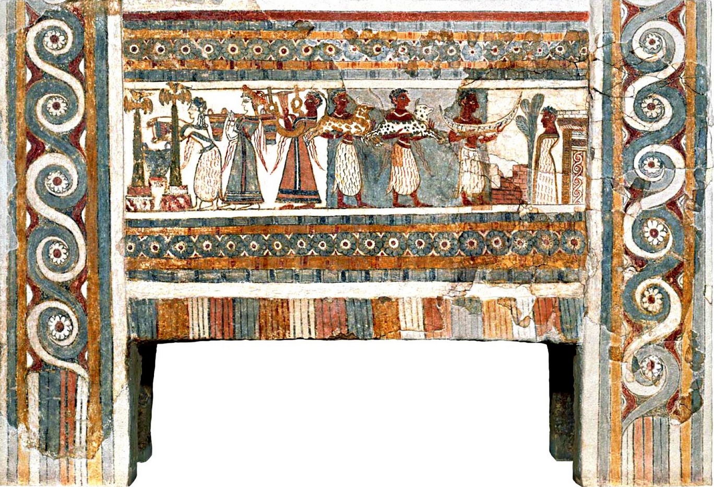

Sarcophagus of Agia Triada (1450 BCE) – detail Side 2. Width 4 feet, 6 in. Archaeological Museum of Herakleion. After https://www.pinterest.com/offsite/?token=796-649&url=https%3A%2F%2Fi.pinimg.com%2Foriginals%2F2a%2Ff0%2F3c%2F2af03c1df7fcfa7040d5442f42b6f428.jpg&pin=527061962636600607&client_tracking_params=CwABAAAADDMwMjA0NDYxNTQ4OAA~0

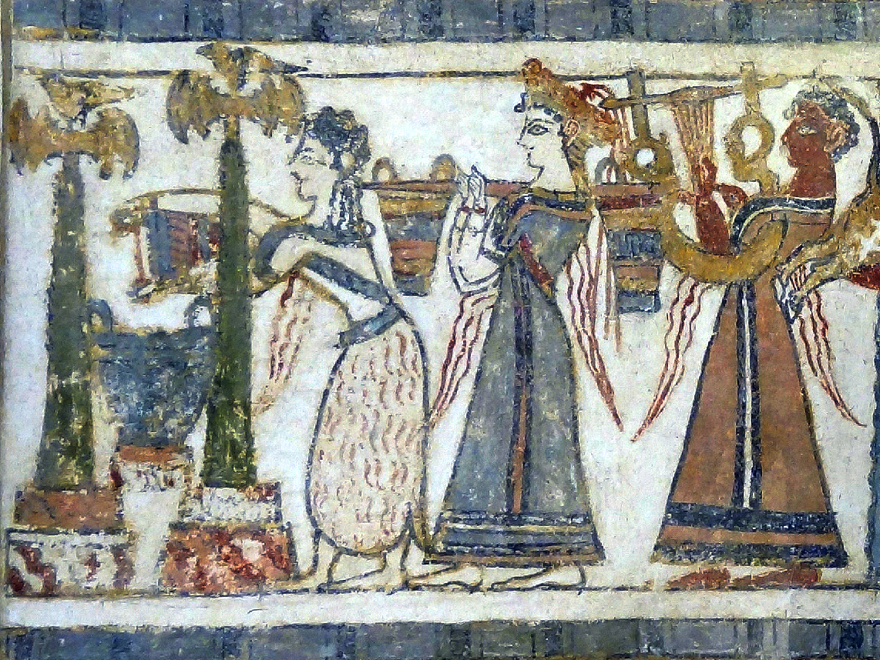

Side 2, left, of the Sarcophagus of Agia Triada. This is a scene of three barefoot figures approaching a Bull Cult Shrine. The first is a priestess wearing a woolen skirt and a blue-striped blouse with her hair in the Minoan sacred knot. She is delivering sacrificial bulls’ blood to a krater in a shrine flanked by two labrys (double axes) both of which are surmounted by the Minoan Dove-goddess, Aphrodite, who rose from the sea at Paphos in Cyprus every year with her virginity renewed. She is also dripping blood signified by undulating red lines. The second is a goddess identified by a golden crown surmounted by long red tassels and braided hair. She wears a blue dress with a black and brown stripe. She is carrying on her right shoulder a yoke with two equally weighty vessels presumably full of bulls’ blood. The third figure is a ruddy-colored musician playing a lyre. This individual has short curly black hair (whose sex is indeterminate) and is wearing a brown robe with a black and white stripe. Sarcophagus of Agia Triada (1600 - 1450 BCE) – detail Side 2 left. Archaeological Museum of Herakleion, By Olaf Tausch [GFDL (http://www.gnu.org/copyleft/fdl.html) or CC BY 3.0 (https://creativecommons.org/licenses/by/3.0)], from Wikimedia Commons

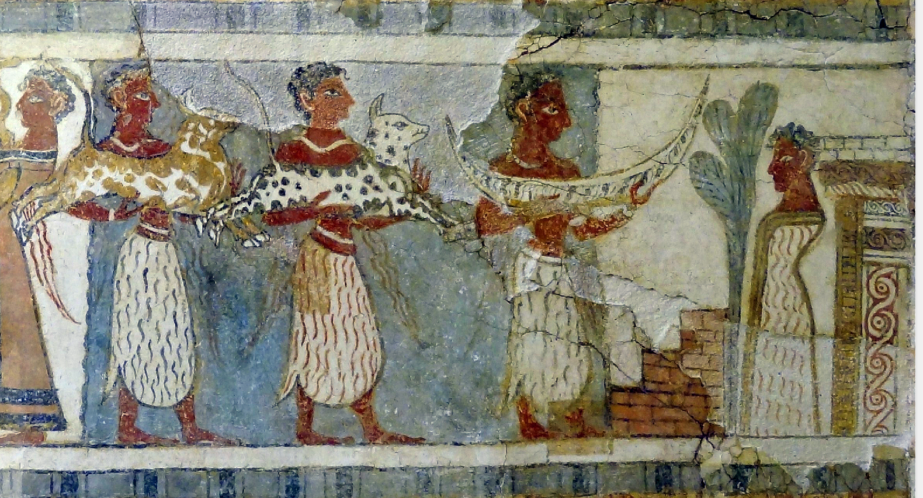

Side 1, right, of the Sarcophagus of Agia Triada. This is a scene of three barefoot priests who are all dressed in sheepskin kilts. Two are carrying sacrificed bulls (and are dripping blood signified by undulating red lines) and a third is carrying a crescent-shaped bowl presumably full of bulls’ blood (and he is also dripping blood signified by undulating red lines). They are in a procession to a Bull Cult Temple, before which is an armless deity ensconced in a full-length sheepskin tunic and before whom is a sacred palm tree. Sarcophagus of Agia Triada (1600 - 1450 BCE) – detail Side 2 right. Archaeological Museum of Herakleion, By Olaf Tausch [GFDL (http://www.gnu.org/copyleft/fdl.html) or CC BY 3.0 (https://creativecommons.org/licenses/by/3.0)], from Wikimedia Commons

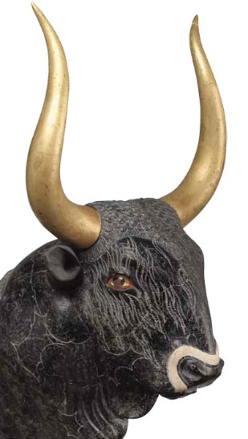

The famous Bull’s Head rhyton from the Little Palace at Knossos was made from serpentine. It has been reconstructed with inlays of shell, rock crystal, and jasper in the muzzle and eyes. The gilt wooden horns have also been reconstructed. This rhyton was dated to the Final Palace period, ca. 1450–1400 BC.

A deep-rooted tension between the wildness of the bull and the need to master it also appears to underlie the most famous Minoan institution involving bulls: bull-leaping. Various depictions of bull-leaping are shown on ceramics, seals, rings, ivory figurines, and frescoes. Based on these artistic representations, Sir Arthur Evans, excavator at Knossos, believed that the process consisted of four clearly defined phases as the leaper approached, grasped the bull by the horns, vaulted over onto the animal’s back, and then sprang onto the ground.

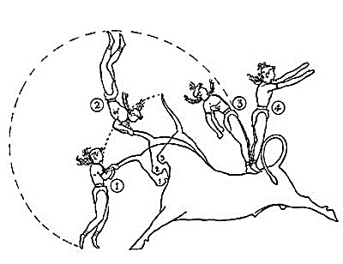

Sir Arthur Evans’ “diagrammatic sketch of [an] acrobat’s course” showing the sequence of movements in bull-leaping. From The Palace of Minos, page 223, fig. 156.

Subsequent studies by A. Sakellariou and John Younger assembled evidence for variations on Evans’ schema until a range of styles was identified and associated with specific periods in Late Minoan culture. These changes in style make little sense divorced from an actual practice; they are therefore taken as evidence that bull-leaping did occur. The conclusion of Younger’s 1976 study sums up the connection between artistic representations and the performances they recall: “In conclusion, bull-leaping begins to appear in artistic representations toward the beginning of the Late Bronze Age in Crete and on the Mainland. The main system of performance probably followed that of the Diving Leaper Schema. When bull-leaping itself was discontinued, perhaps towards the close of the LB IIIA or the beginning of the LB IIIB period, 1340 BC[E], later representations depicted the leaper in the floating pose (Type III), a pose not copied directly from the sport.” The ceremonial courts characteristic of Minoan palaces are often taken to be the locations for the sport, serving as Minoan bull-rings.

The lack of any Minoan liturgical text before Crete had come under Greek control such as the myths of Pasiphae and Minos, underscores the difficulty in recreating the particulars of Bronze Age religion. Although we do not have Minoan myths about the stars, it is probable that astrological traditions of the Near East were familiar to the Minoans. Although bull leaping scenes are based on actual performances those events are to be understood within the structure of the Bronze Age cosmological background of Orion, Taurus, and Andromeda that then became part of the cosmological structure of the later Greeks.

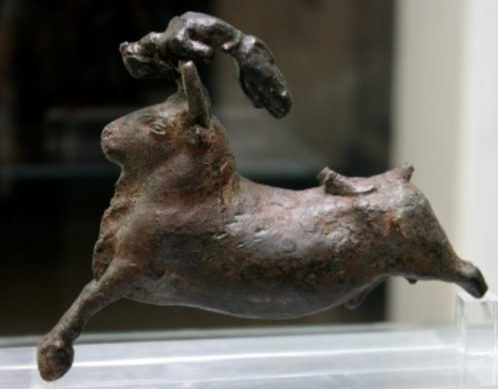

“Bronze Group of a Bull and Acrobat”. This cast bronze figurine from Rethymnon, Crete, Late Minoan I (dated to ca.1700–1450 BCE) shows an acrobat somersaulting between a bull’s horns and over its head. It measures 11.4 cm in height. BM Image #1966,0328.1. The relative size of the bull and the jumper depicted here indicates that it is the extinct Auroch species.

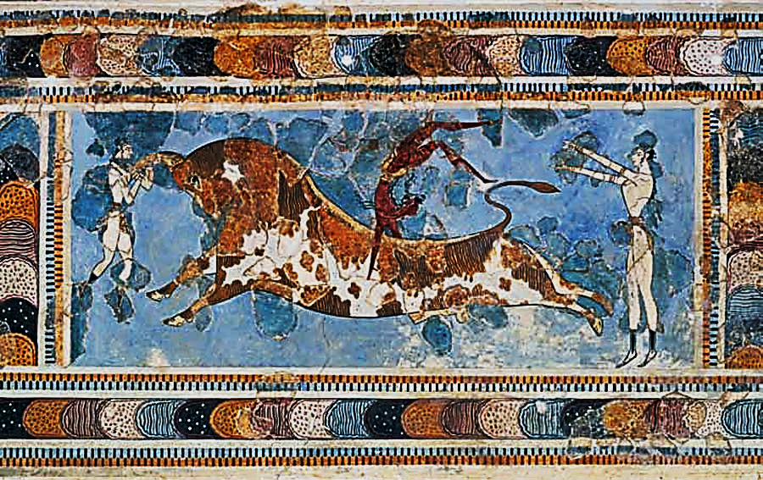

The Bull-leaping fresco, at the palace at Knossos, depicts a white male figure standing ready to jump between the bull’s horns while a ruddy male figure somersaults off the bull’s back as a comrade, standing with both arms extended, is ready to spot his landing safely. The relative size of the bull and the jumper depicted here indicates that it is the extinct Auroch species. Final Palace period, ca. 1450–1400 BCE. From the British Museum. After <https://encrypted-tbn0.gstatic.com/images?q=tbn:ANd9GcQE6IwlxESfcxPAVmvCSOJ1QBdaXOkWgVKlM_rJckguZAh0U-UA>

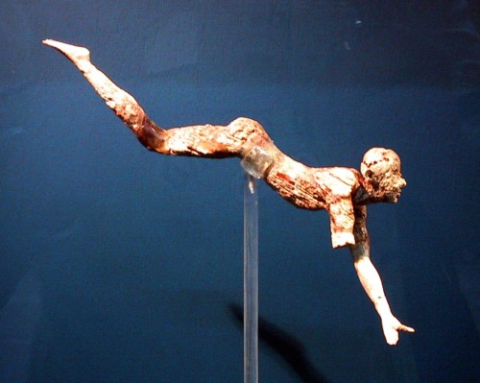

An ivory figurine of a bull leaper was probably part of a three-dimensional composition depicting bull-leaping. Recovered from Knossos, New Palace period, ca. 1600–1500 BCE. After https://78.media.tumblr.com/732cace761eabebd26a23294f123ec44/tumblr_inline_nms9tr94sO1t79fgm_500.jpg

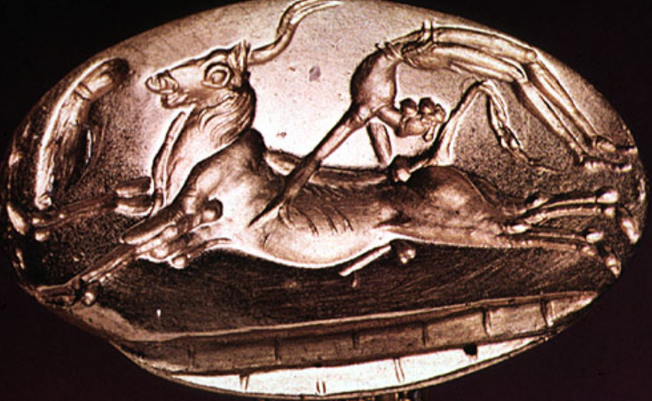

A male figure somersaults off the bull’s back. The relative size of the bull depicted here indicates that it is the extinct Auroch species. Gold Minoan signet ring ca. 1600-1450 BCE, after http://0fa3028f16a92a7d04b1-09cd1c78e27a390ecb7695ec980834cf.r91.cf2.rackcdn.com/images/originals/2011/09/23/04g.jpeg

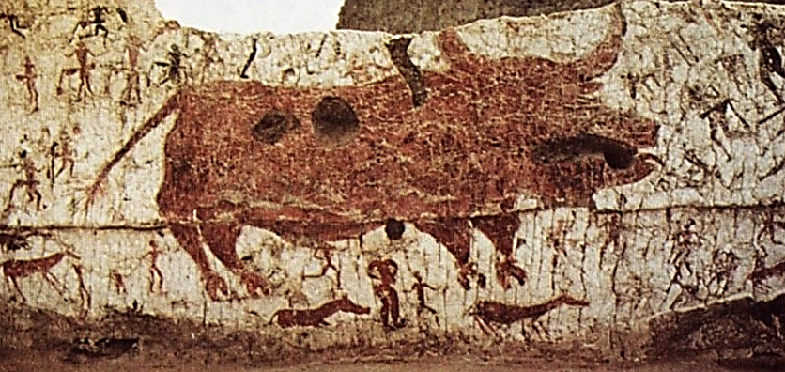

Anatolian Çatal Hüyük (ca 6500 BCE) painting of a bull of the extinct Auroch species. after <https://i.pinimg.com/originals/27/d3/40/27d34055d4e0a53d1b87c5a7f360fa7f.jpg>.

The prominence of bull spirituality in Anatolian Çatal Hüyük suggests that Crete was the recipient of ancient spiritual ideas from the Anatolian Neolithic.



A reconstructed shrine of a bull cult at Çatal Hüyük of the extinct Auroch species (ca 6500 BCE) After <https://assets.atlasobscura.com/media/Musée> des Civilisations anatoliennes.

Minoan wall paintings have also been recovered from the western edge of the ancient Hyksos period city of Tell el-Dab‘a (Avaris) in Egypt.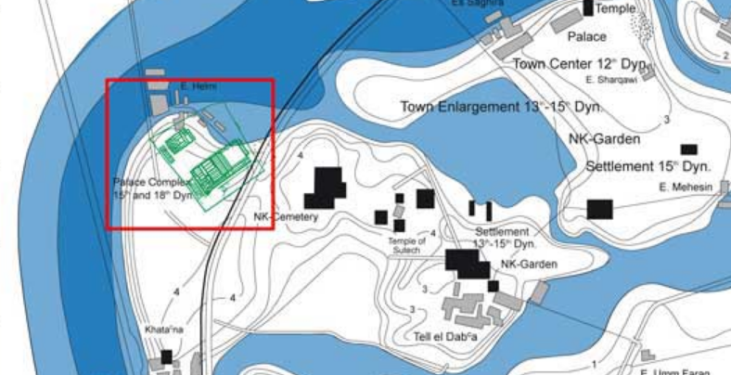 In the late Hyksos Period and the 18th Dynasty the Tell el-Dab‘a (Avaris) site fulfilled the situation of a royal residence, which in Egypt is mostly situated to the north of the town and near the river. After http://www.auaris.at/html/helmi43_en.html

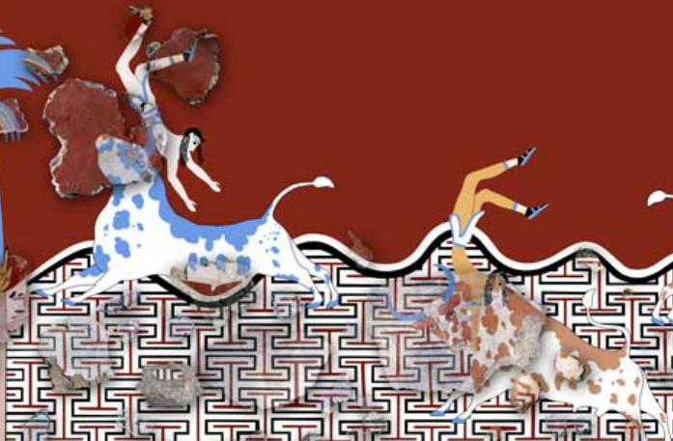

At Tell el-Dab‘a (Avaris) during the late Hyksos Period (stratum D/2) scenes of bull-leaping ca 1500 BCE above undulating waves of the Aegean separating Egypt from Crete and, below, a Cretan Labyrinth. Note, however, the relative size of the bulls are that of the Auroch type found in Late Palatial Crete. After http://www.auaris.at/html/helmi43_en.html

At Tell el-Dab‘a (Avaris) scenes of bull-leaping and a Cretan Labyrinth dating ca 1500 BCE confirm the expansion of the Bull Cult to Egypt, which was in contact with Late Palatial Crete.

The Bull Cult leaping ritual performance by expert athletes demonstrates that Cretan religion reflected the effort to demonstrate that *homo religioso’s* mastery of the bull provided him with an assured place as an intermediary to the beyond. While depictions of bull-leaping, though popular at Knossos, are uncommon at the other Minoan palaces. Perhaps Knossos, was not only the origin of Minoan bull-leaping and the Bull Cult but also the source for the institutionalization of the event that was then emulated elsewhere on the island of Crete and then in its diffusion to Tell el-Dab‘a (Avaris).

In the modern French version of the sport, cattle production and specialized training, including maintaining sixteen breeding farms for 1,200 *vaches landaises*, the breed specifically raised for the sport, and maintaining *écolnot onlles taurines*, training schools for the *toreros.*

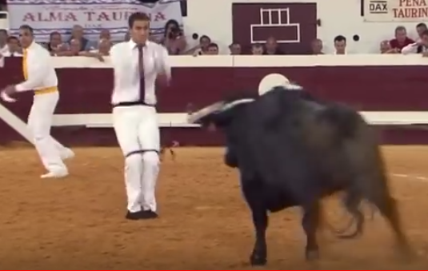

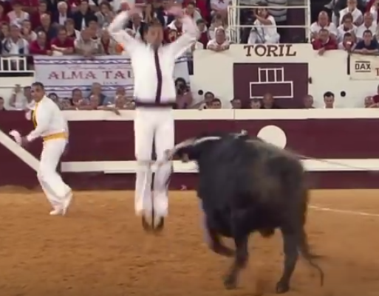

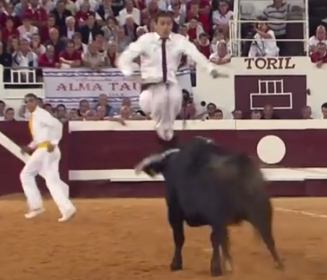

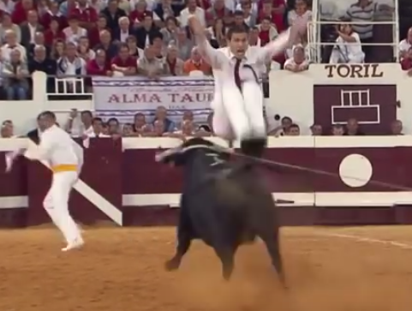

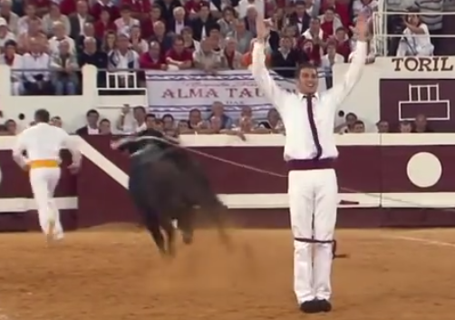

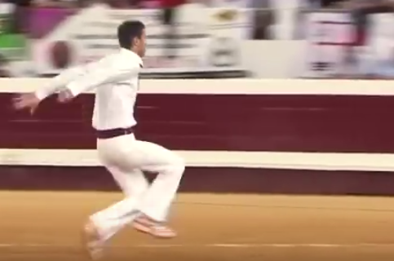

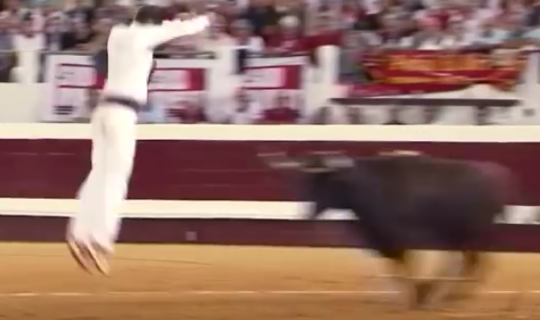

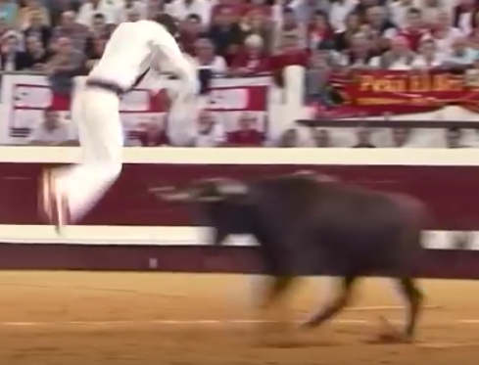

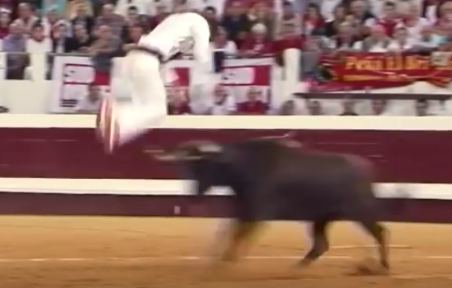

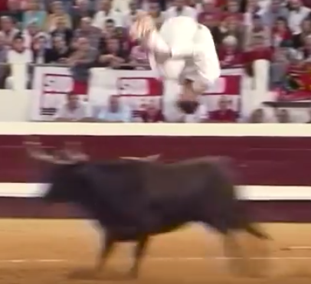

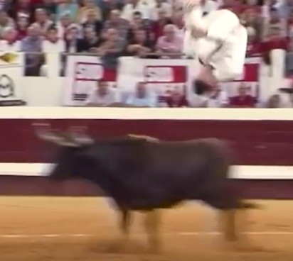

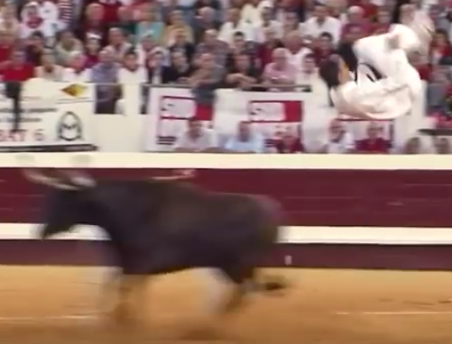

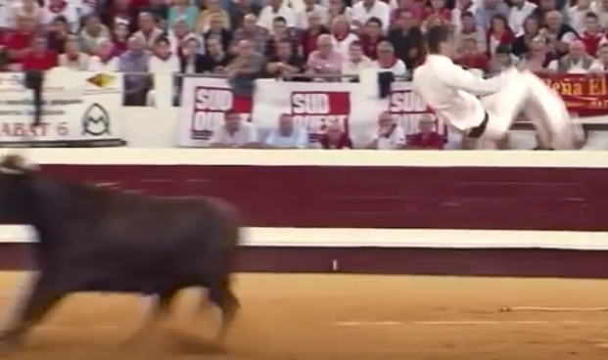

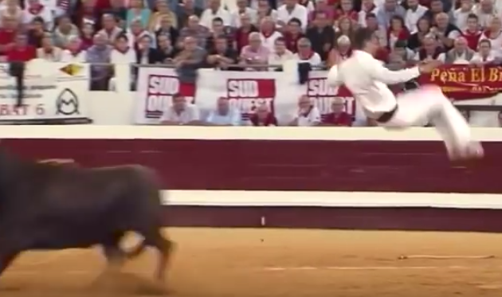

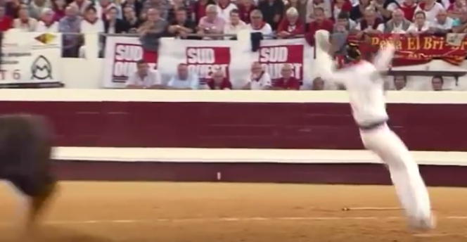

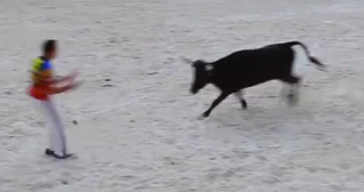 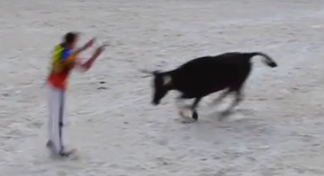

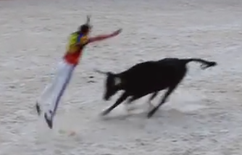 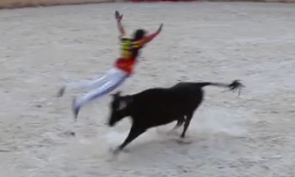 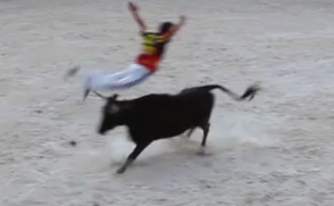 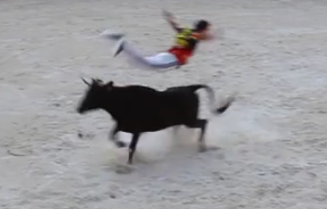 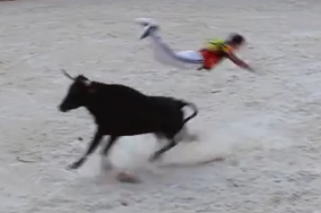 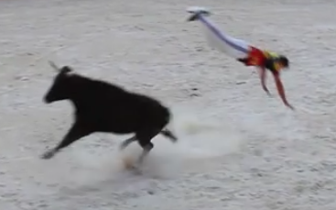

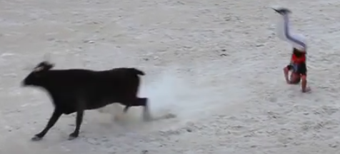 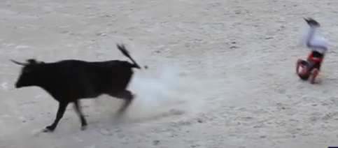

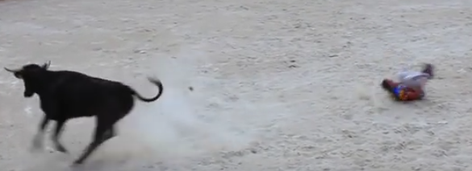

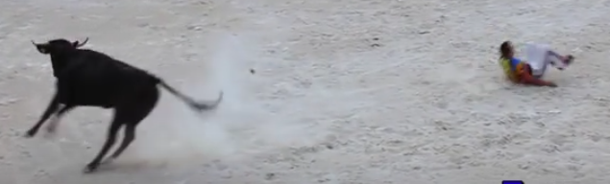

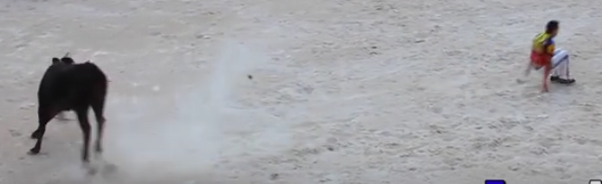 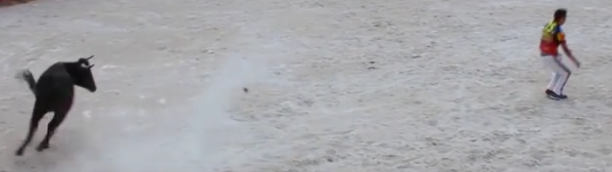 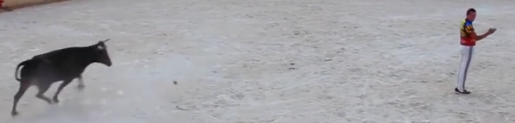 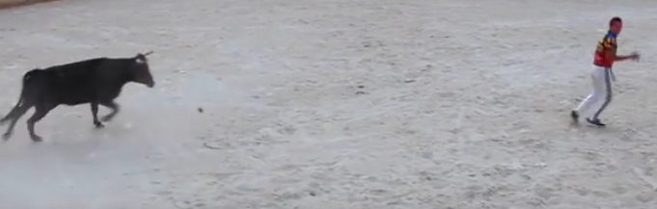

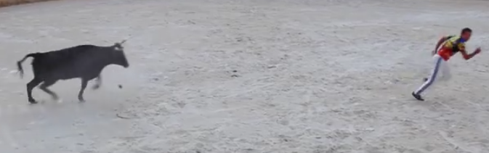

The *Sauteur* somersalts and jumps over a bull at the *Cours Landaise Larrivière* in Aquitaine, Gascony. After

The comparison of the Minoan Bull Jumping Cult with the *cours landaise* indicates that the bull in both cases was not ritually slain. The bull jumper was the athlete who symbolized, metaphorically, an intermediary between bovine and human nature. The *cours landaise* as well as the *cours minoienne* requires a bull-leaping institution predicated on a cadre of expert, devoted young athletes and a bull-breeding program.

**LC Classification:**

**Date or Time Horizon:** 1450 BCE

**Geographical Area:** Knossos

**Map:**

**GPS coordinates:**

**Cultural Affiliation:** Late Palatial Minoan, 1450 BCE

**Medium:** original, polychrome ceramic

**Dimensions:**

**Weight: original,** 1 kg (2.2 pounds) empty and 3 kg when full

**Condition: resin replica**

**Provenance:**

**Discussion:**

**References:**

Appendix

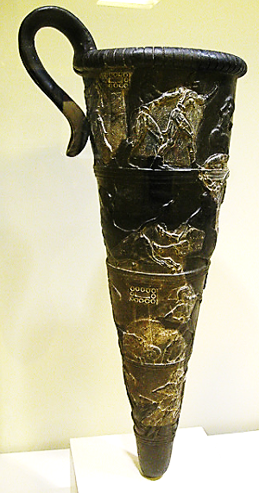

The "boxer rhyton", with scenes of boxing, wrestling and bull-leaping, found in Agia Triada. From the 15th century BC.

Archaeological Museum, Iraklion, Crete, Greece.